Terraform – 03

Execute the script shown in the video.
- By using interactive mode (This will get activated if we don’t pass default vale in variable.tf file)
- Goto visual studio and open main.tf file and now create variable.tf and then don’t pass the values in it
- After applying the terraform apply it will ask values to enter
- This type is called as interactive mode
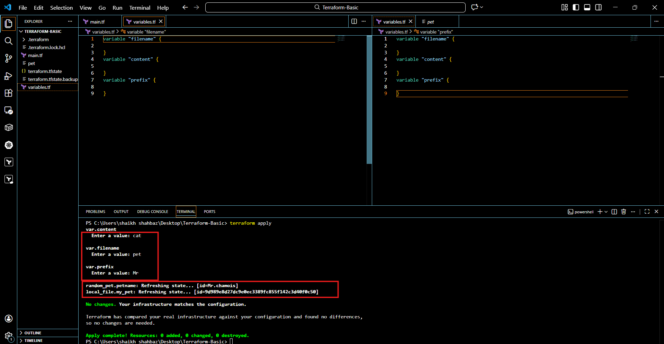
- By using variables.tf file (Input or default variable)
- We have to define variable in variable.tf file itself so that it will take the values
- After entering the values, in terminal execute terraform apply after saving the values
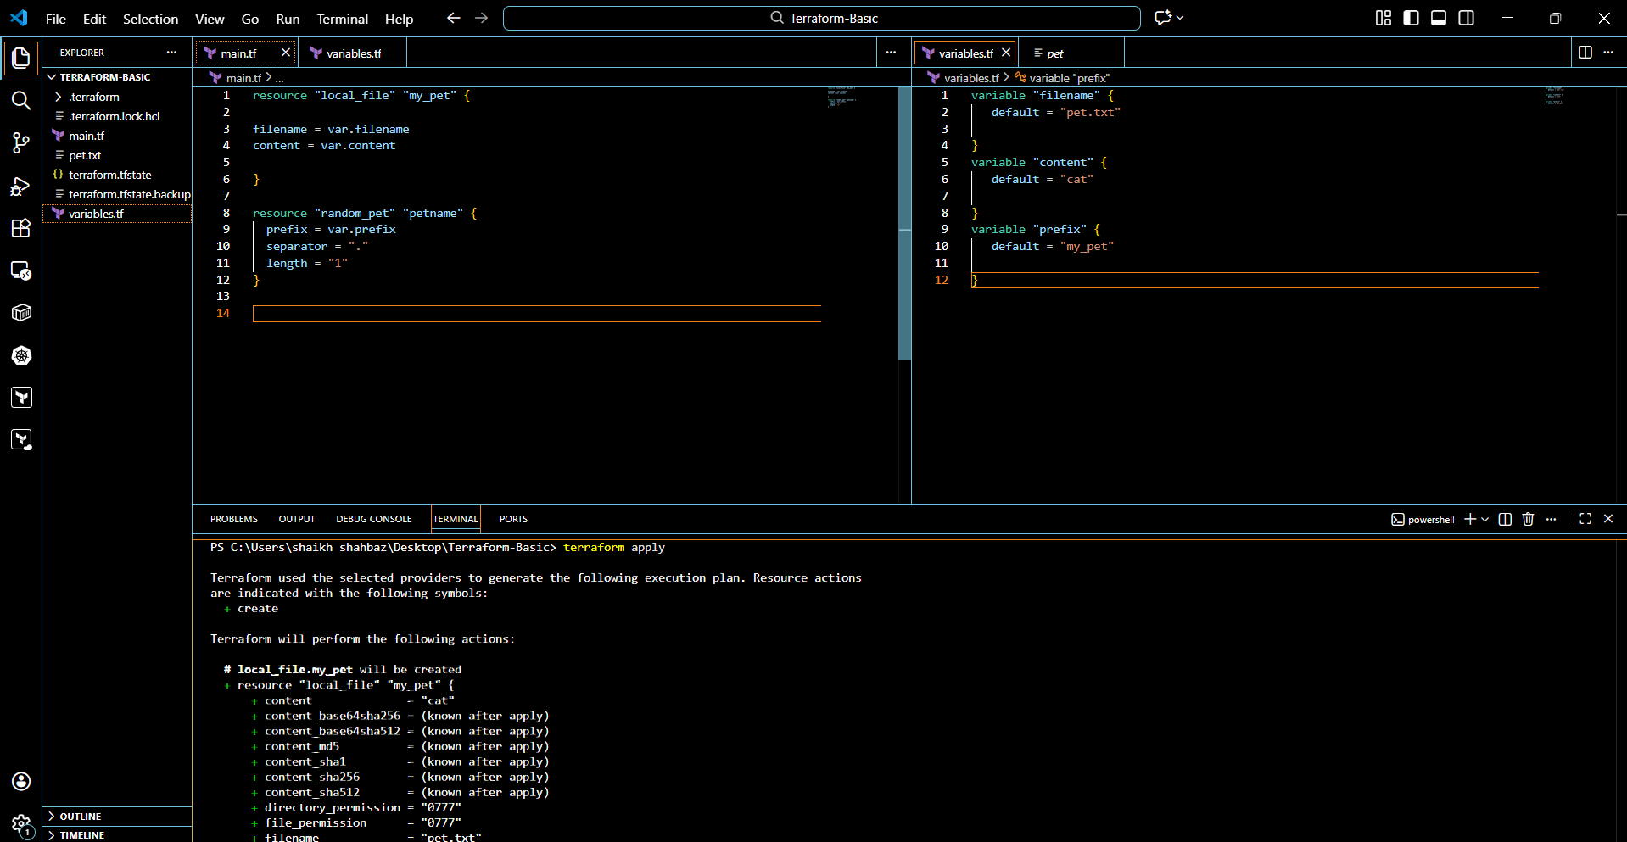
- Environment Variables (TF.VAR)
- We have to provide values on using TF_VAR as shown in the image
Set-Item -path env:TF_VAR_filename -value “wild txt”
Set-Item -path env:TF_VAR _content -value “I love cat”
Set-Item -path env:TF_VAR_prefix -value “MISS”
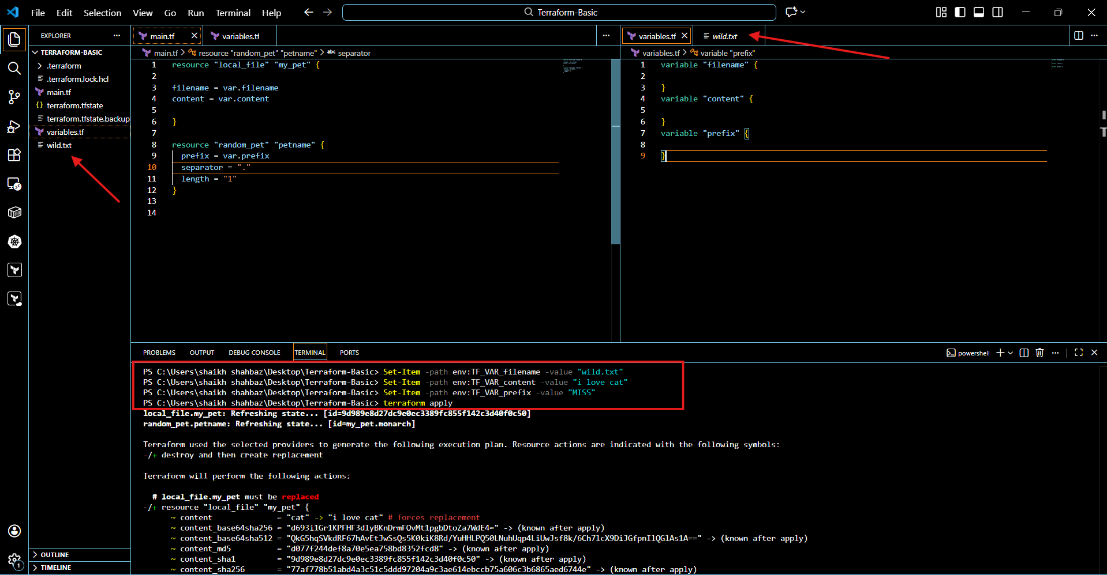
- Command line flags:
terraform apply -var “filename=/root/pets.txt” -var “prefix=MR”
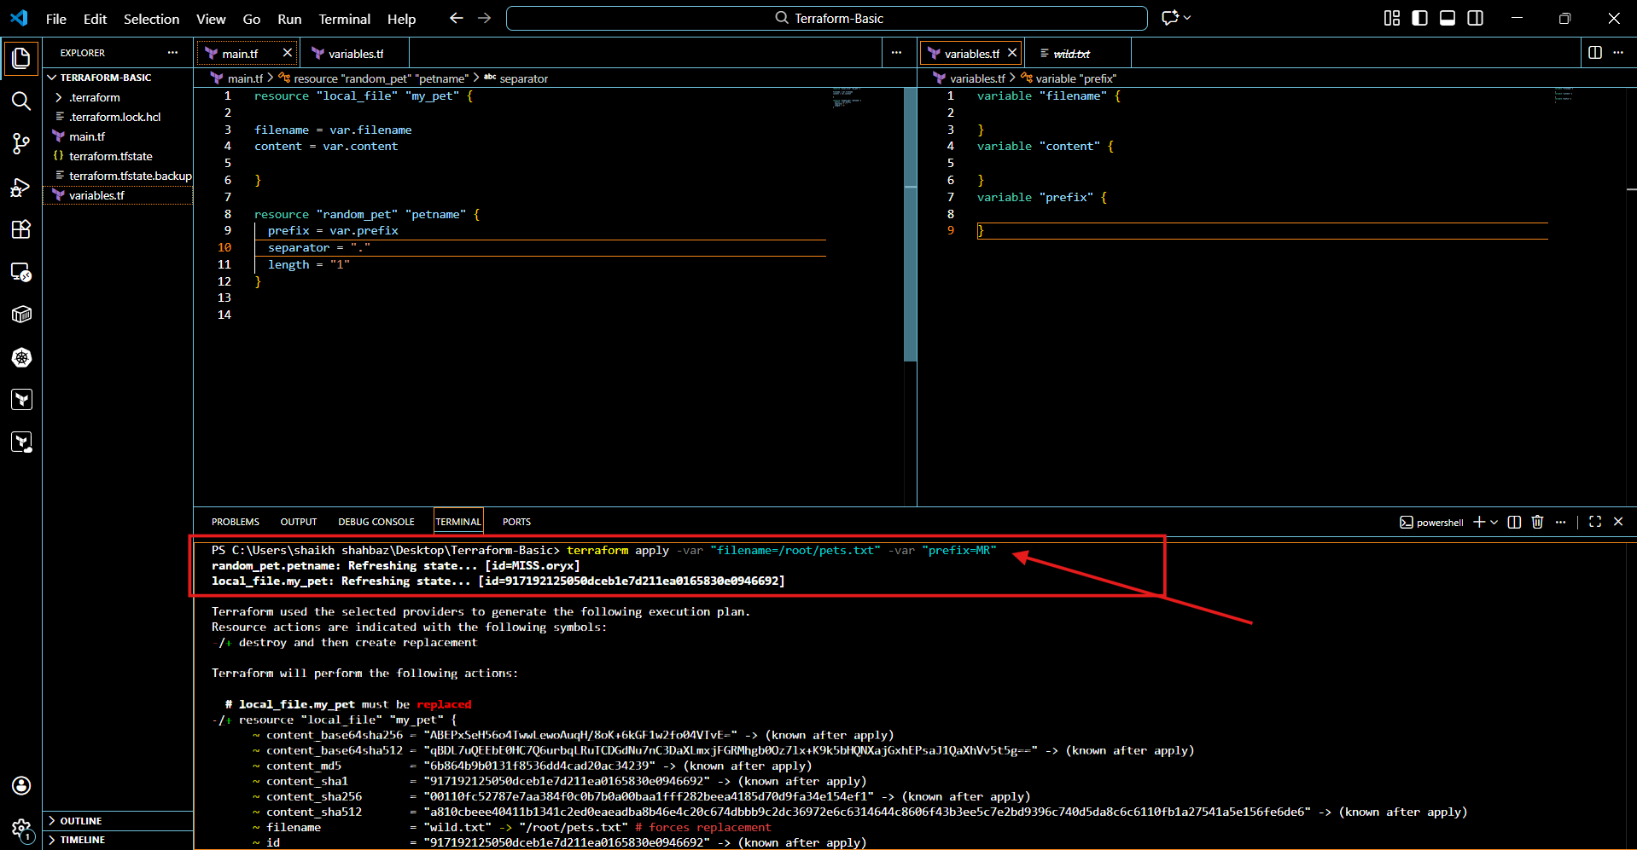
- Variable definition file (Should be end with terraform.tfvars/terraform.tfvars.json)
- For automatically loaded file name *.auto.tfvars/*.auto.tfvars.json
- If we are saving the file with other name like variable.tf.vars then we need to pass this in CLI
- terraform apply -var-file variable.tfvars
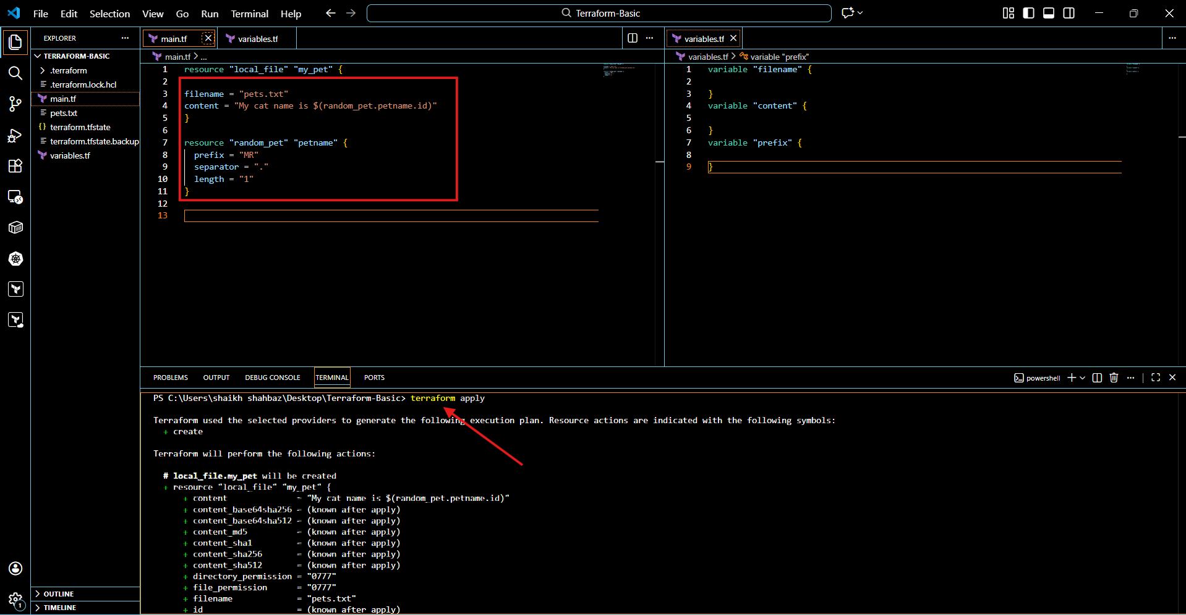
OUTPUT VAIABLE:
- Add output variable in main.tf then execute terraform apply
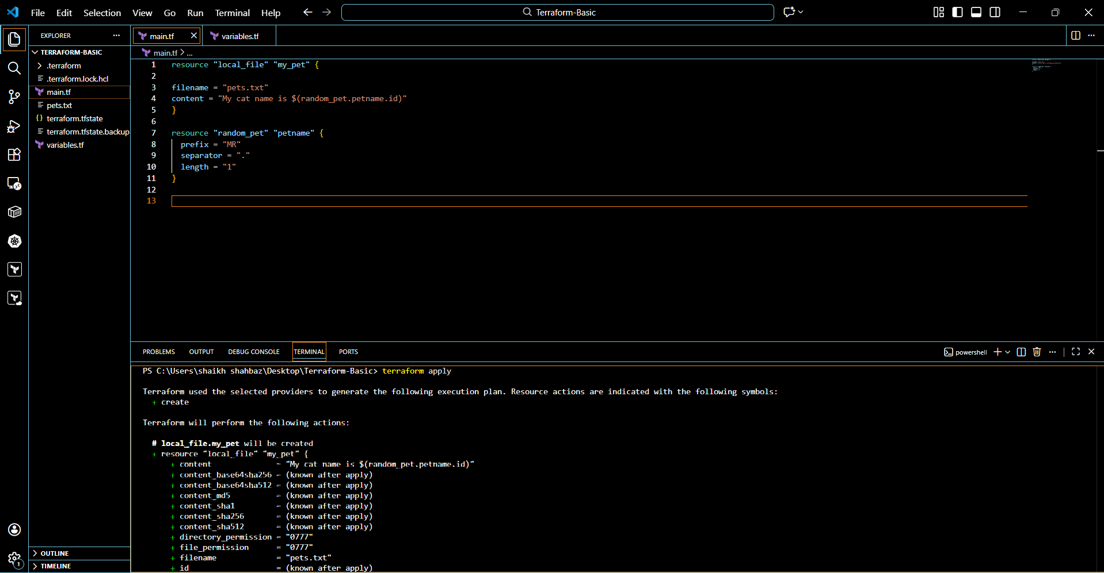
- Random name is provide and displayed the output as well.
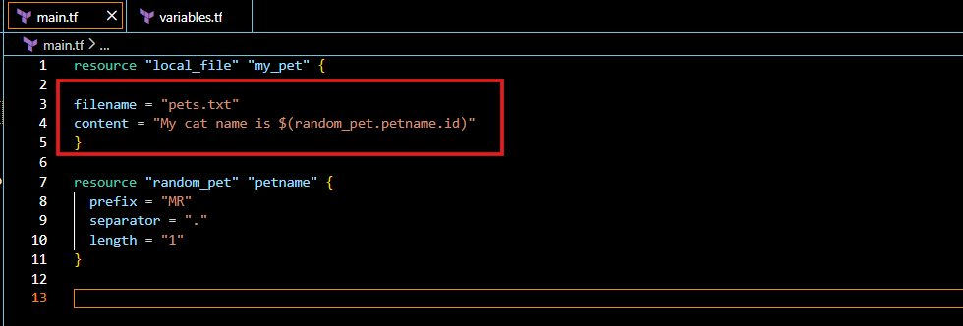
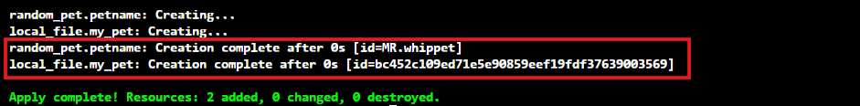

Integrate Terraform in Jenkins using the Terraform plugin.
- Install terraform in CLI from official terraform site
- After installing terraform check the version to make sure
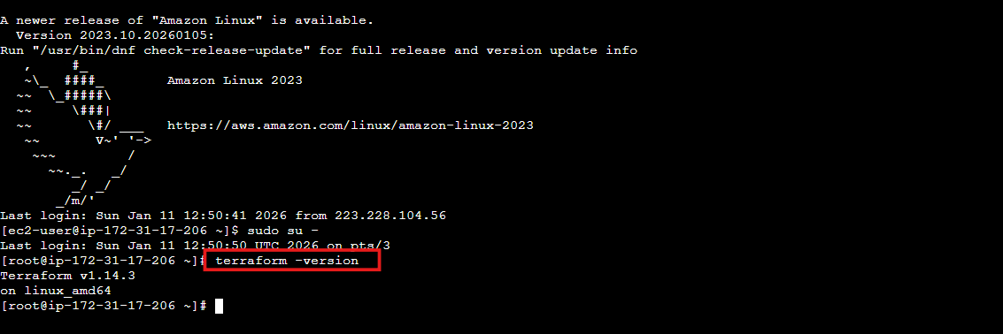
Part A – Integrate Terraform in Jenkins (Terraform Plugin)
1. Install Terraform Plugin
- Jenkins Dashboard → Manage Jenkins
- Manage Plugins → Available
- Search Terraform
- Install Terraform Plugin
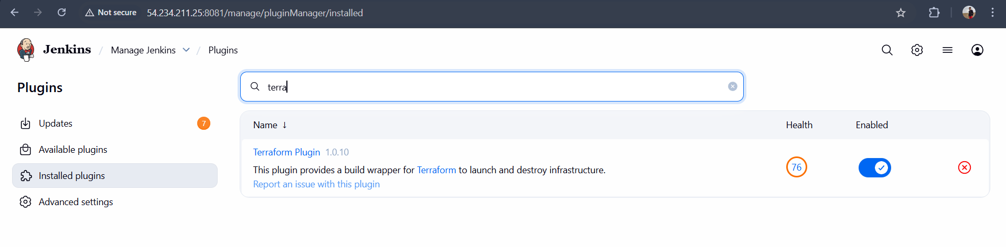

2. Configure Terraform Globally
- Manage Jenkins → Global Tool Configuration
- Scroll to Terraform
- Click Add Terraform
- Configure:
- Name: terraform
- Install automatically
- Choose Terraform version
- Save
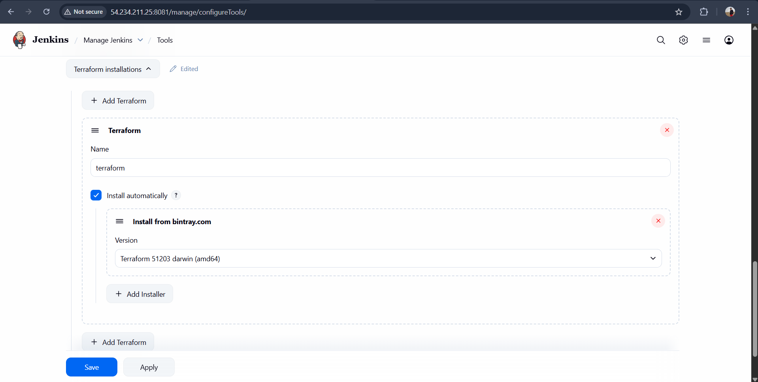

Create one Jenkins job using Maven Project for the code below with two stages:
Part B – terraform-job-01 (Maven Project – Non-Parameterized)
Job Type
Maven Project

1. Create Job
- New Item
- Name: terraform-maven-job
- Select Maven Project
- Click OK
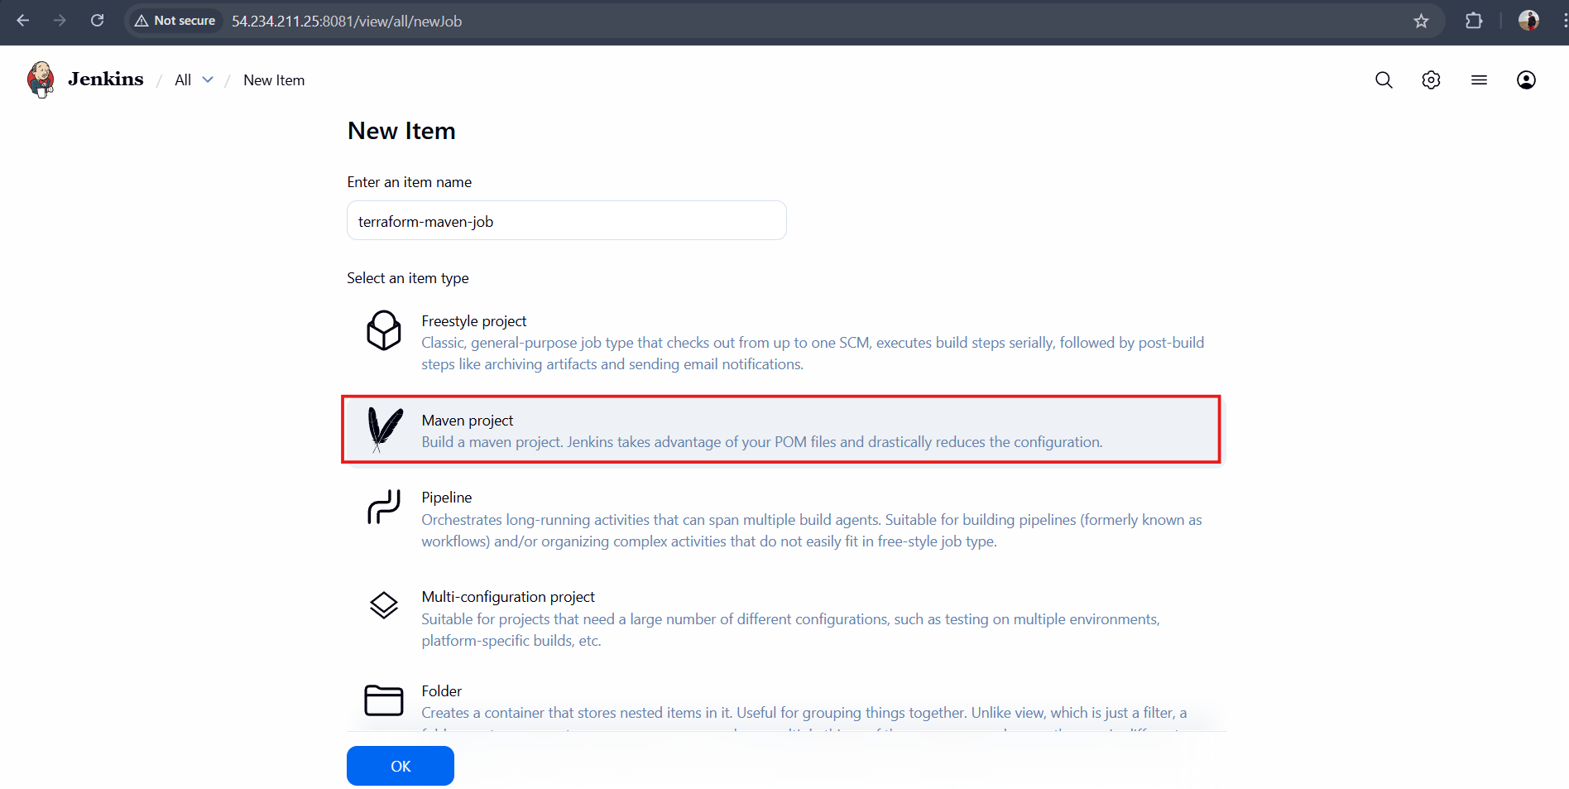

Stage 1: Git clone
2. Stage 1 – Git Clone
Under Source Code Management:
- Select Git
- Repository URL:
https://github.com/betawins/java-Working-app.git
- Branch: */main
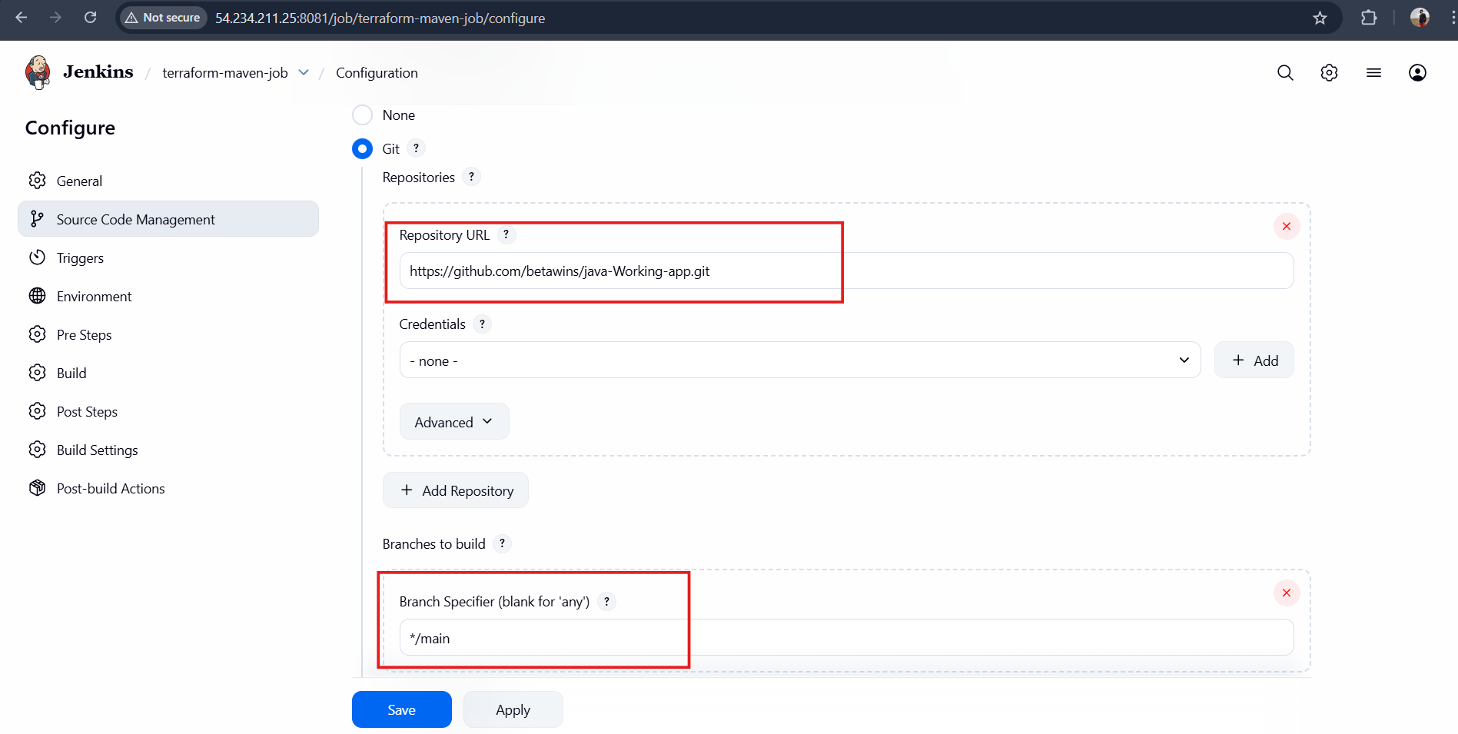
3. Stage 2 – Maven Compilation
Under Build:
- Goals and options:
clean compile
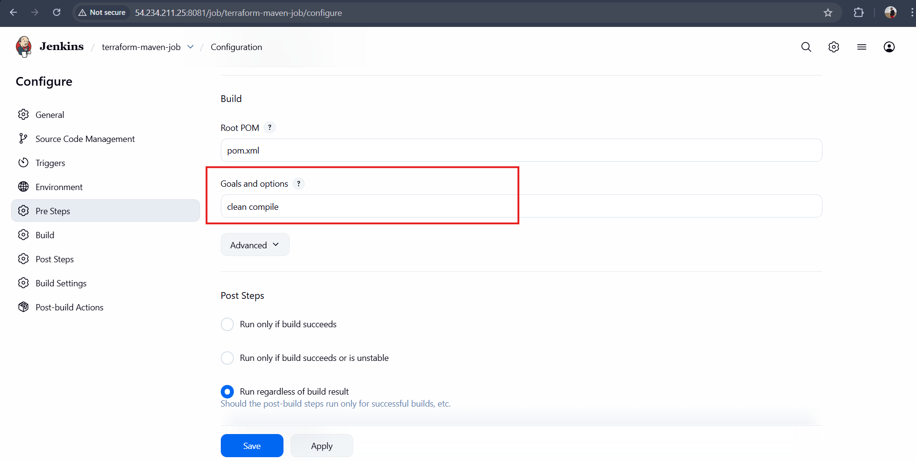
Save and Apply
Click Build Now
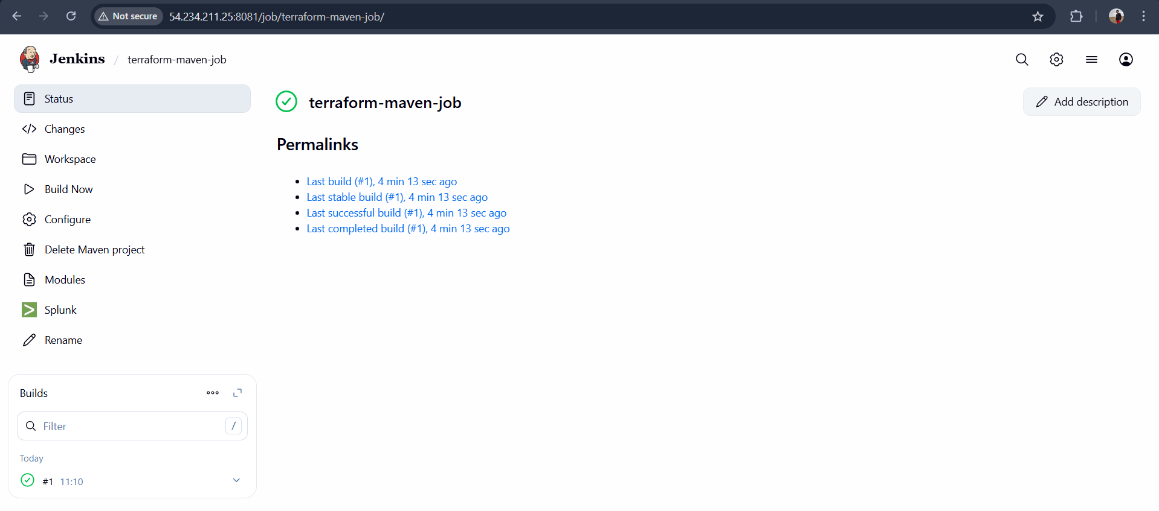
Final Flow
Stage 1: Git clone
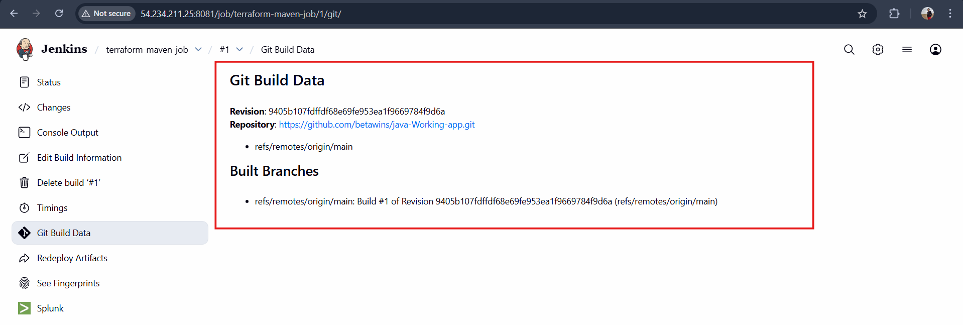
Stage 2: Maven compile
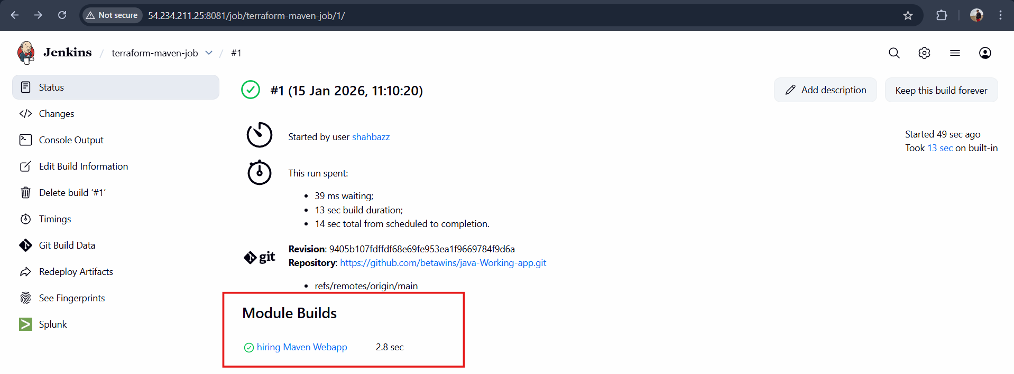

Stage 2: Maven Compilation Code: https://github.com/betawins/java-Working-app.git
Part C – Jenkins Job 2 (Parameterized Maven Project)
1. Create Job
- New Item
- Name: terraform-maven-param-job
- Select Maven Project
- Click OK
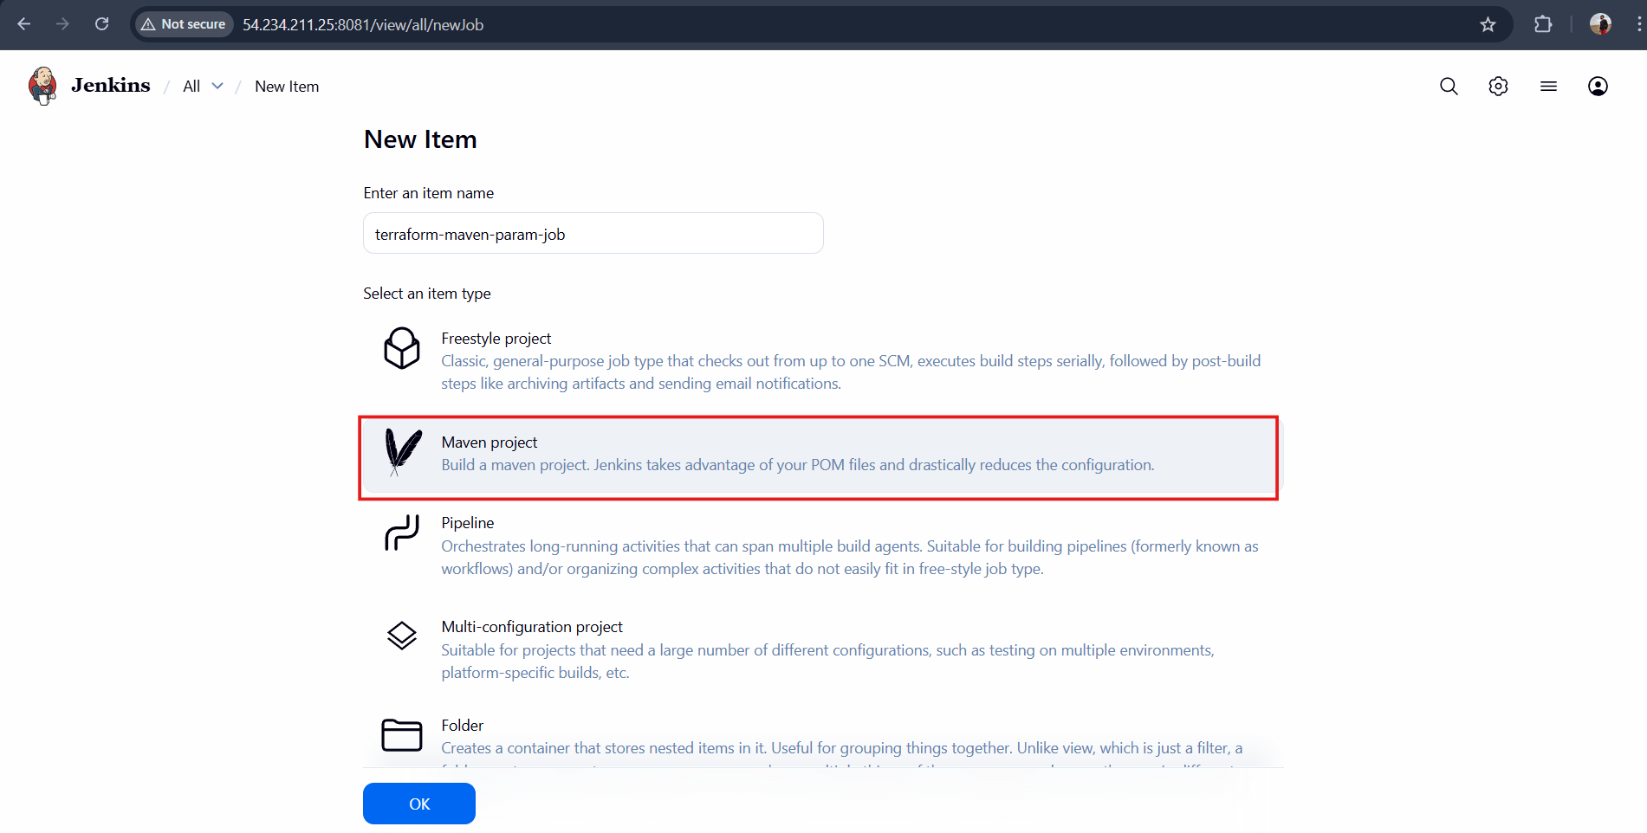

Use the same code and create a parameterized job in Jenkins with:
2. Add Parameters
Check This project is parameterized
- Goto new job you have crated and click configure
- Now select “This job is parameterised” and select option as “string parameter”
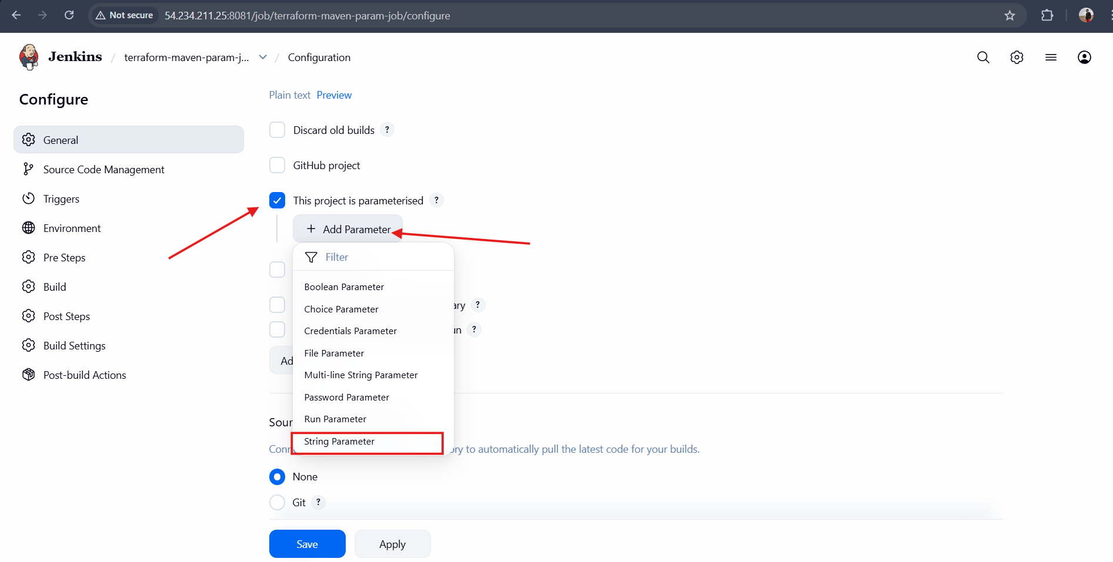
Add:
- String Parameter
  - Name: BRANCH
  - Default: main
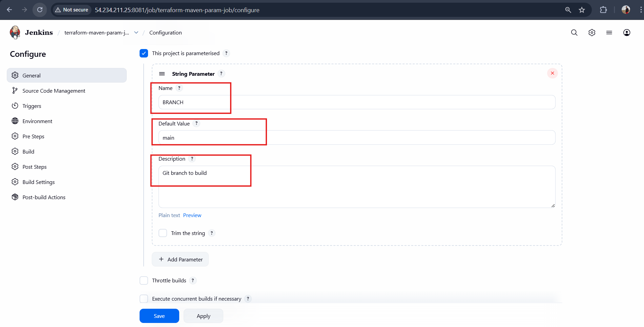

Stage 1: Git clone
3. Stage 1 – Git Clone (Parameterized)
Source Code Management → Git
- Repository URL:
https://github.com/betawins/java-Working-app.git
- Branch:
*/${BRANCH}
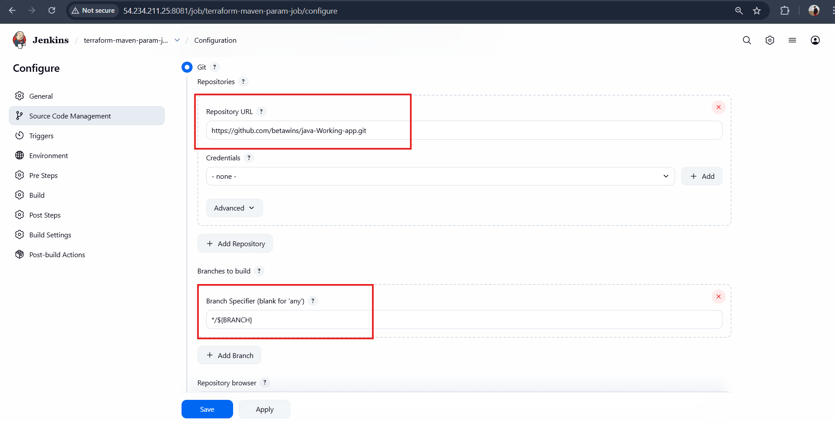
Stage 2: Maven Compilation Code: https://github.com/betawins/java-Working-app.git
4. Stage 2 – Maven Compilation
Build → Goals and options
clean compile
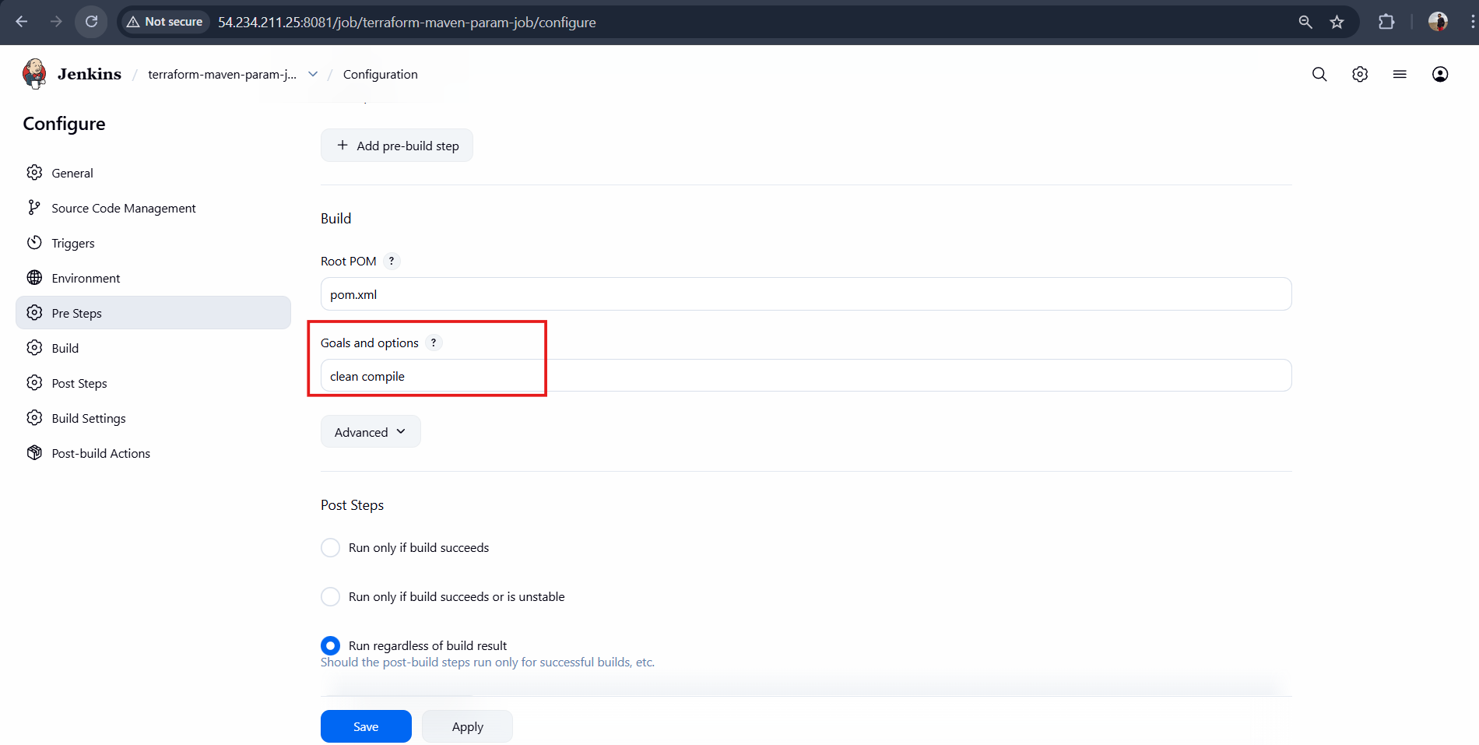
  - Save the job and then click on “Build with parameters”
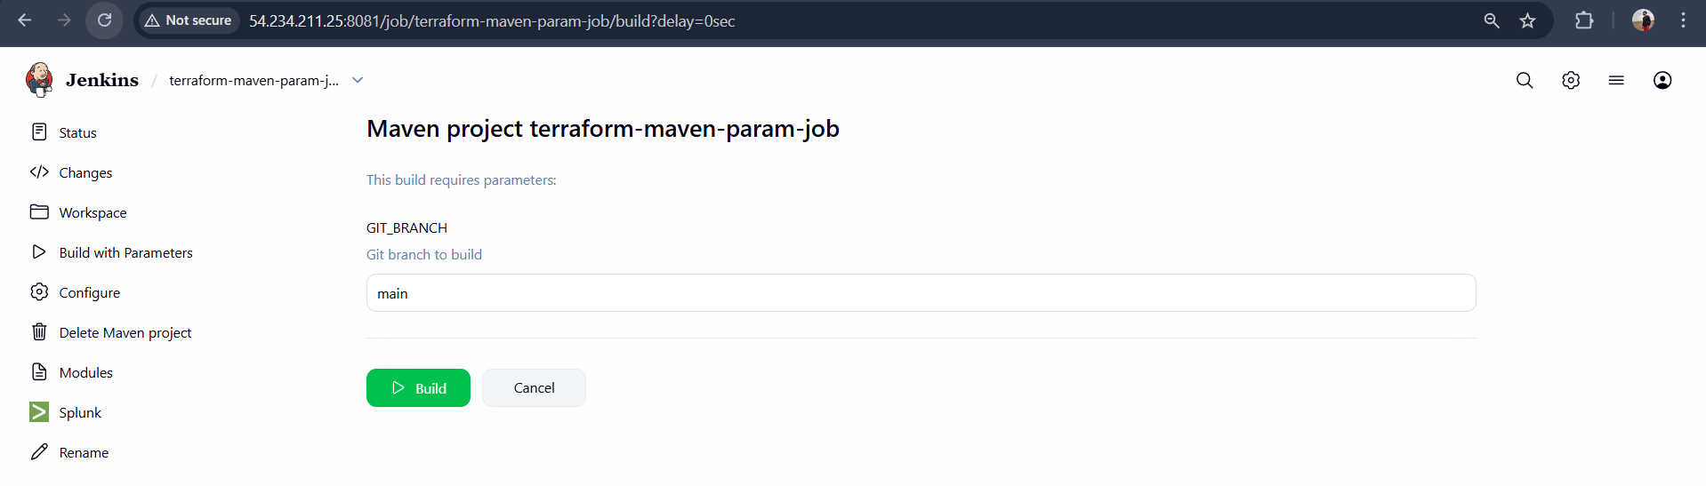
BUILD OUTPUT:
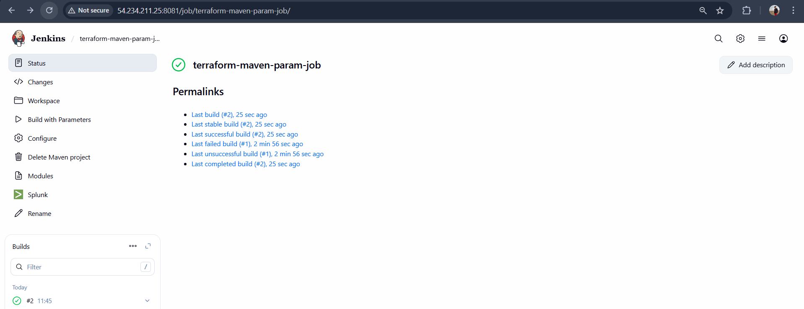
  - Check for parameters
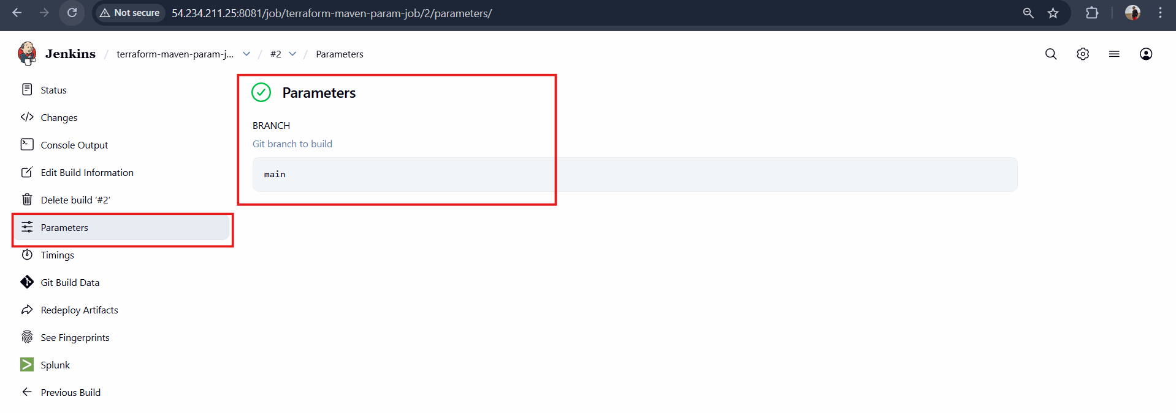

What are the global variables in Jenkins?
Part D – What Are Global Variables in Jenkins?
Global Variables in Jenkins
Definition:
Global variables in Jenkins are predefined environment variables that are automatically available to all Jenkins jobs and pipelines. They provide information about the build, job, workspace, node, and Jenkins system.

1. Build-Related Global Variables
BUILD_NUMBER Current build number
BUILD_ID Unique ID of the build
BUILD_TAG Jenkins build tag
BUILD_URL URL of the current build
BUILD_DISPLAY_NAME Display name of the build
BUILD_CAUSE Reason the build was triggered

2. Job-Related Global Variables
JOB_NAME Name of the Jenkins job
JOB_BASE_NAME Job name without folder path
JOB_URL URL of the Jenkins job

3. Workspace and Node Variables
WORKSPACE Directory where the job is executed
NODE_NAME Name of the node running the job
NODE_LABELS Labels assigned to the node
EXECUTOR_NUMBER Executor number running the build

4. Jenkins System Variables
JENKINS_HOME Jenkins home directory
JENKINS_URL Jenkins server URL
JAVA_HOME Java installation path

5. Git-Related Global Variables
GIT_BRANCH Git branch being built
GIT_COMMIT Commit ID
GIT_URL Git repository URL
GIT_AUTHOR_NAME Commit author name
GIT_COMMITTER_NAME Committer name

Example Usage in Jenkins
echo "Job Name: $JOB_NAME"
echo "Build Number: $BUILD_NUMBER"
echo "Workspace Path: $WORKSPACE"

